Bodily Maps of emotions in chronic pain

International Association for the Study of Pain (IASP) defines pain as “ An unpleasant sensory and emotional experience associated with, or resembling that associated with, actual or potential tissue damage”. Acute pain usually consists of nociceptive activity that can be seen to activate somatosensory areas (S2, ACC, insula, thalamus and PAS) in functional brain imaging studies. The experience of acute pain may be modulated by mood, attention and expectations. Pain lasting more than three months or that it recurs, is considered chronic pain. In brain imaging studies, there seems to be a shift of activation from sensory networks towards the emotional networks in chronic pain[1]. Pain activates classic fight or flight responses that prepare the body to protect itself. The physiological responses can be also felt on the body.

Emotions prepare us for action and influence our behavior. Emotions are often accompanied by bodily sensations that may be due to physiological reactions to the same activator. Behind these sensations are for example activation of the autonomic nervous system, increasing heart rate and breathing. This in order to make the body ready to react. These sensations can be defined in bodily sensation maps (BSMs). Participants are shown human silhouettes and emotional words. They are asked to paint those body areas whose activity is either activated or downregulated while having each feeling. BMSs are very specific for basic feelings. These maps are not related to cultural or linguistic background and are so thought to be part of the somatosensory system and somatotopic maps.

Previously, bodily sensations of emotions using BMSs have been studied in healthy populations in different social and cultural contexts (REF)and also in a group of schizophrenia patients[2]. In schizophrenia, the bodily sensations and experience of feelings are often abnormal. These anomalous changes were also seen on BMSs. Considering both the sensory input from nociceptors and the crucial role of emotion in pain, chronic pain patients would be a highly interesting group to study using BMSs.

The activation of brain circuits may be altered in chronic pain. These alterations may vary between different chronic pain states like complex regional pain syndrome (CRPS), chronic back pain (CBP) or fibromyalgia.

CRPS patients have been shown to have often negative feelings towards the affected limp. Neglect symptoms and body perception disturbances are also common. Fibromyalgia is a chronic pain state characterized by high sensitivity to touch particularly to pressure. Pain is usually widespread and felt in the muscles. Patients are usually easily fatigued and prone to have depression and sleep problems. CBP patients are a quite heterogenic group. Usually patients have psychosocial symptoms and motion pattern dysfunctions.

Pain can affect e.g. behavior, mood and autonomic responses. In chronic pain changes in the central nervous system can also be seen. Emotions and pain seem to be interwoven. We evaluated depression, anxiety and BMSs in chronic pain patients. We hypothesize that the emotional maps differ between pain patients and healthy controls and that this may lead to new ways to evaluate and treat pain.

-kroonisen kivun vaikutukset mielialaan, ja kognitiiviseen toimintakykyyn

-kivun muutos verkoissa tarkemmin

-FM ja CRPS aivo ja psl vaikutukset vielä laajemmin

-Muuttuvatko kartat, onko kiputiloilla eroa -> voiko käyttää vaikeusasteen/keston evaluaatiossa? Hoidon vaikutuksen seurannassa? Miten vaikuttaisi hoitoon.

Mieti vielä intron kappaleiden järjestystä. Minusta 2 ensimmäistä kappaletta ovat oikeassa järjestyksessä, mutta sen jälkeen tulevat eivät ehkä. Viimeisessä kappaleessa tulisi yrittää vetää yhteen aiemmin sanottua ja kertoa sitten mitkä olivat tutkimuksemme hypoteesit.

**Methods**

***Participants***

The participants consisted of a control group representing the general population and a group of chronic pain patients.

*The control group*

The participants of the control group were recruited from student mailing lists, social media and message boards. at the University of Turku There were no exclusion criteria. First, the controls were asked whether they had any current acute pain. In case the controls asked in the positive, they were asked to answer the Brief Pain Inventory (BPI) (REF). They were asked whether they had any pain that had lasted for 3 months or longer and if so, whether they had a history of migraine, headache, abdominal pain, back and neck pain, limb and joint pain or menstrual pain (kysyttiinkö tämänkin osalta BPI). They were also asked to report the frequency (kuvaa tarkemmin) and type (kuvaa tarkemmin) of current pain medication use.

*Chronic pain patients*

Chronic Pain patients were recruited from the Multidisciplinary Pain Clinic of the Helsinki University Hospital. Inclusion criteria were age over 18 years, fluency in Finnish and ability to use the emBODY tool on iPad. Patients who had major psychiatric conditions, active cancer or who used strong opioids (oxycodone, morphine, methadone, fentanyl, hydromorphone) were excluded. We recruited patients who had wither complex regional pain syndrome (type I or II), fibromyalgia, neuropathic pain or low back pain. The diagnosis was verified by an experienced pain physician.

All patients provided a written informed consent. The study was approved by the Ethics Committee of the Helsinki and Uusimaa Hospital District (HUS/3382/2017).

***Procedure***

Participants evaluated bodily sensations of emotions with the emBODY programme and pain-related e-questionnaires with iPad pro tablets (patients) and online using their own devices (controls). Participants were asked to mark six basic emotions (anger, fear, disgust, happiness, sadness, surprise and neutral state) to related body regions. The emBODY uses 2-dimensional abstract body figures. Participants were instructed to evaluate which body regions feel activated or deactivated when feeling each emotion. Both groups were asked to mark body areas that are sensitive to tactile, nociceptive and hedonic touch. Regions with acute and chronic pain were asked to be marked on a body map. Pain was evaluated with Brief Pain Inventory, short form (BPI). The short form BPI evaluates pain within 24 hours and its impact on mood, walking, working, relationships, sleep, enjoying and life in general. Information about State and Trait Anxiety Inventory (STAI) and Beck Depression Inventory (BDI) were also filled. Demographic data was collected ( age, gender, current diseases and medications). The patients were matched for age and gender. The matched controls were required to have both BPI now and BPI 24hour mean below 5.

Jossain kohtaa pitäisi kanssa mainita, että väritystehtävissä kipupotilailla (mutta ei verrokeilla) oli mahdollisuus myös indikoida, että he ovat jättäneet kyseisen kehon tarkoituksella tyhjäksi (esim. eivät kokeneet kipua missään tai eivät tunne kyseistä tunnetta missään pain kehoaan). Tästä johtuvien vääristymien välttämiseksi oletettiin, että kaikki tyhjät kehot verrokeilla oli tarkoituksella jätetty tyhjäksi (tämä valinta minimoi eroa kipupotilaiden ja verrokkien välillä).

***Statistics***

Subjects who had not colored in at least 10% of pixels inside the mask in at least one of the colouring tasks (emotion maps, sensitivity maps, pain maps) were rejected.

**Results**

Total of 2348 controls and 118 patients were enrolled. Most of the controls had no pain and some had or had had mild acute pain recently. Five patients didn´t fill the chronic pain body map and didn´t mark it done so intentionally.

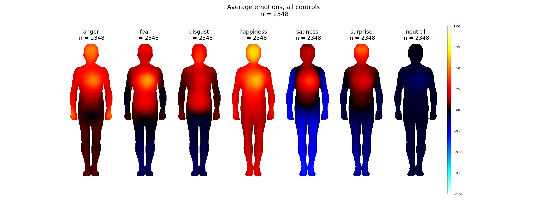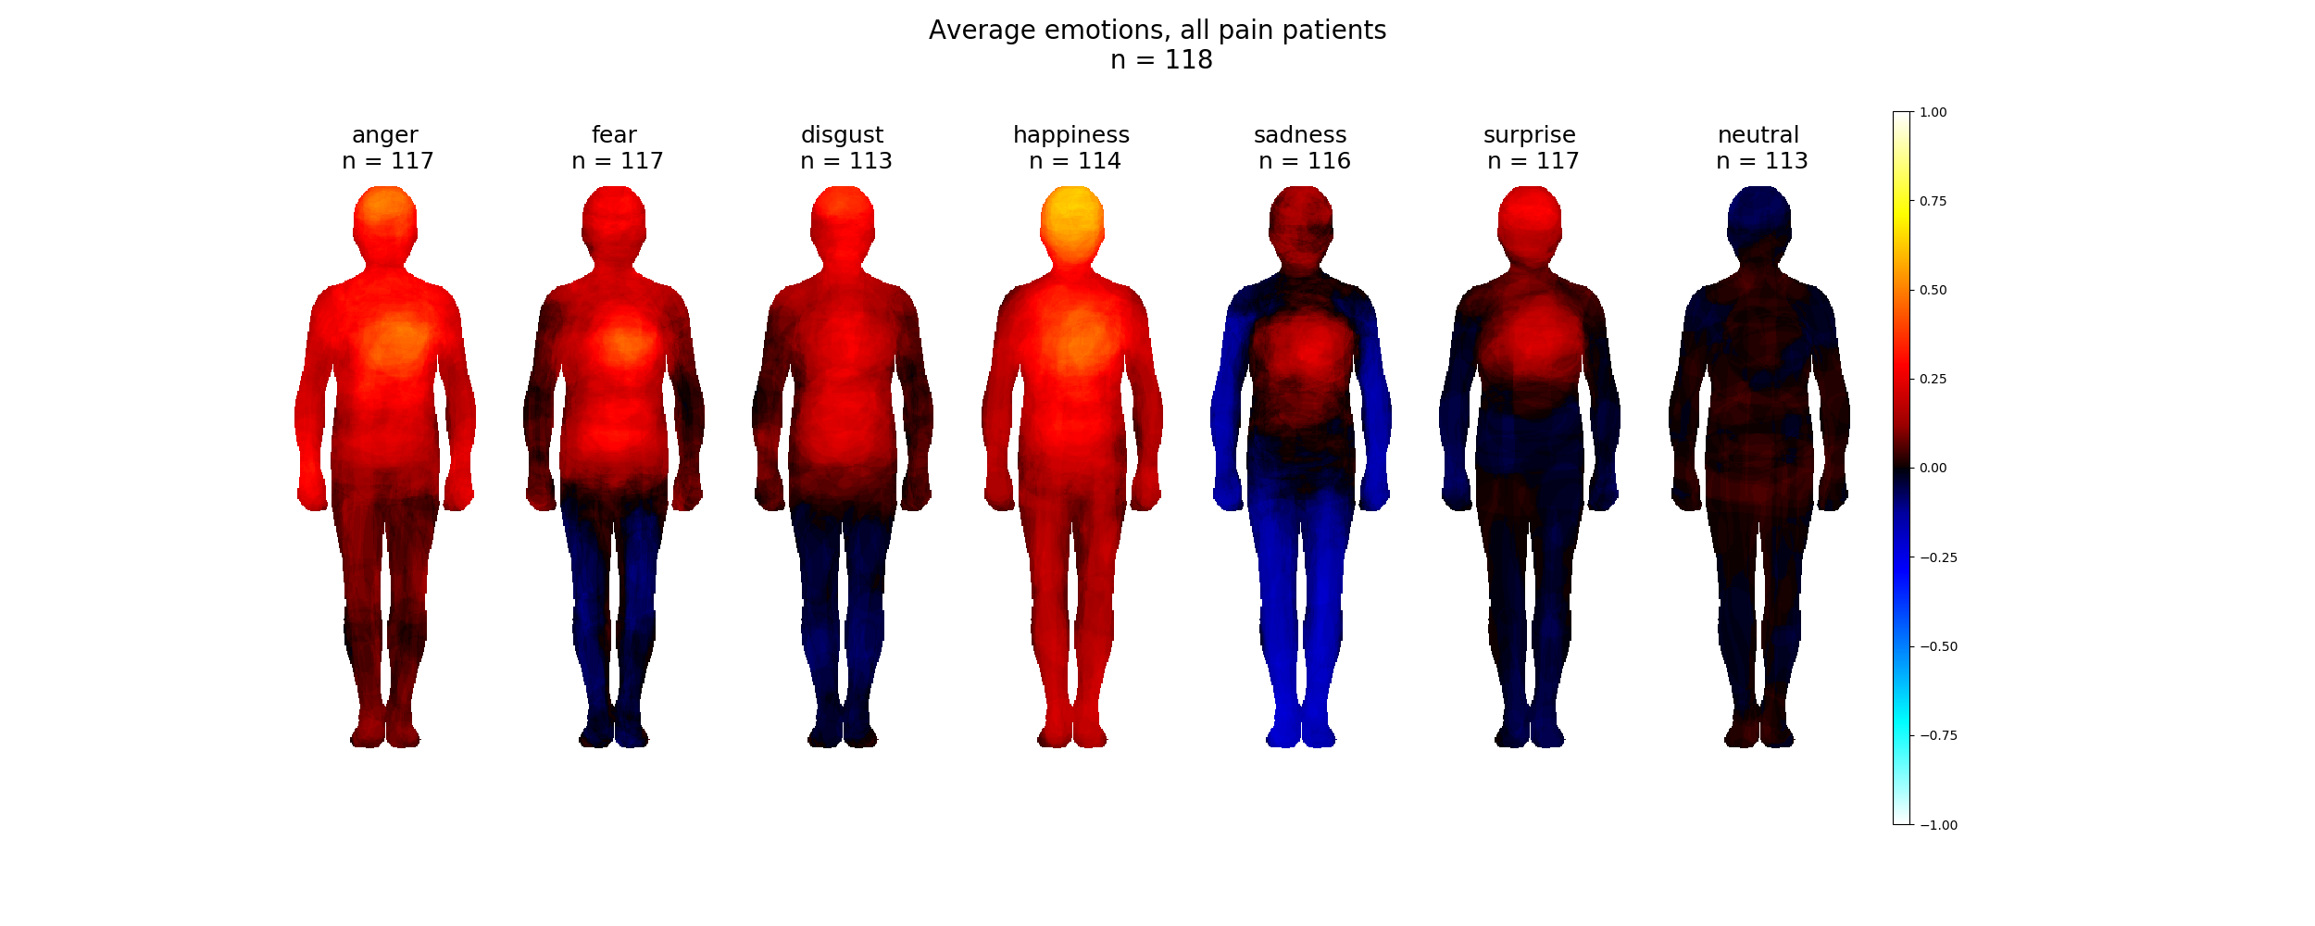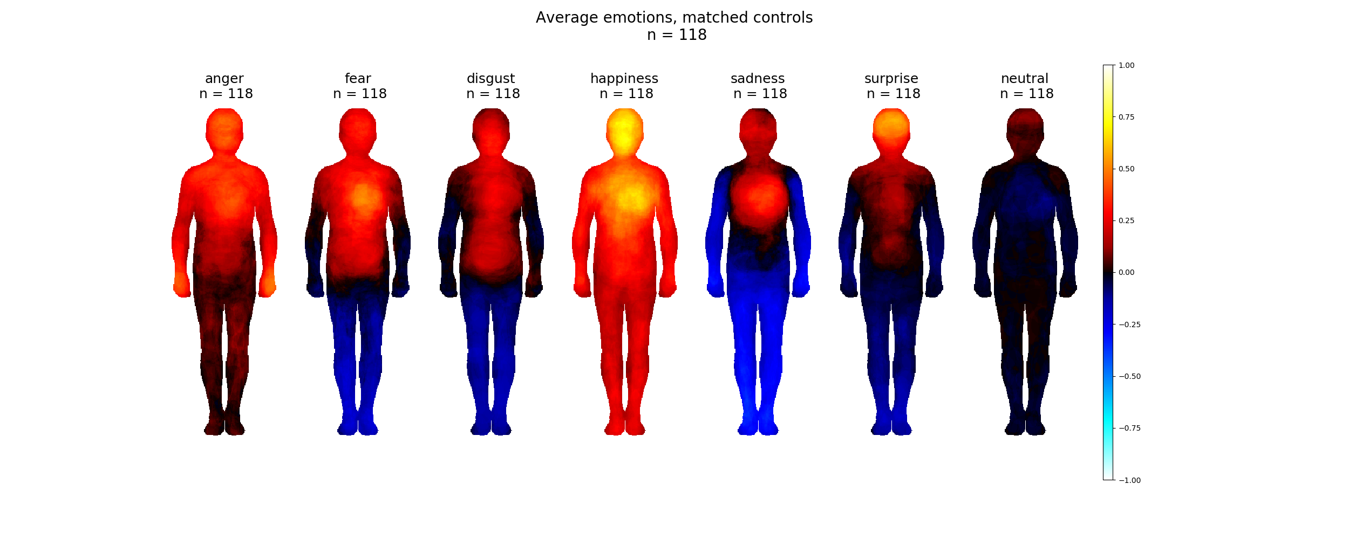

Partisipants painted bodily maps associated with six basic emotions and neutral state. The maps don´t differ on pixel level between pain patients and controls. Still sum effects are different between patients and controls. Generally the activation is lesser in pain patients. Deactivations are also lesser in pain patients.

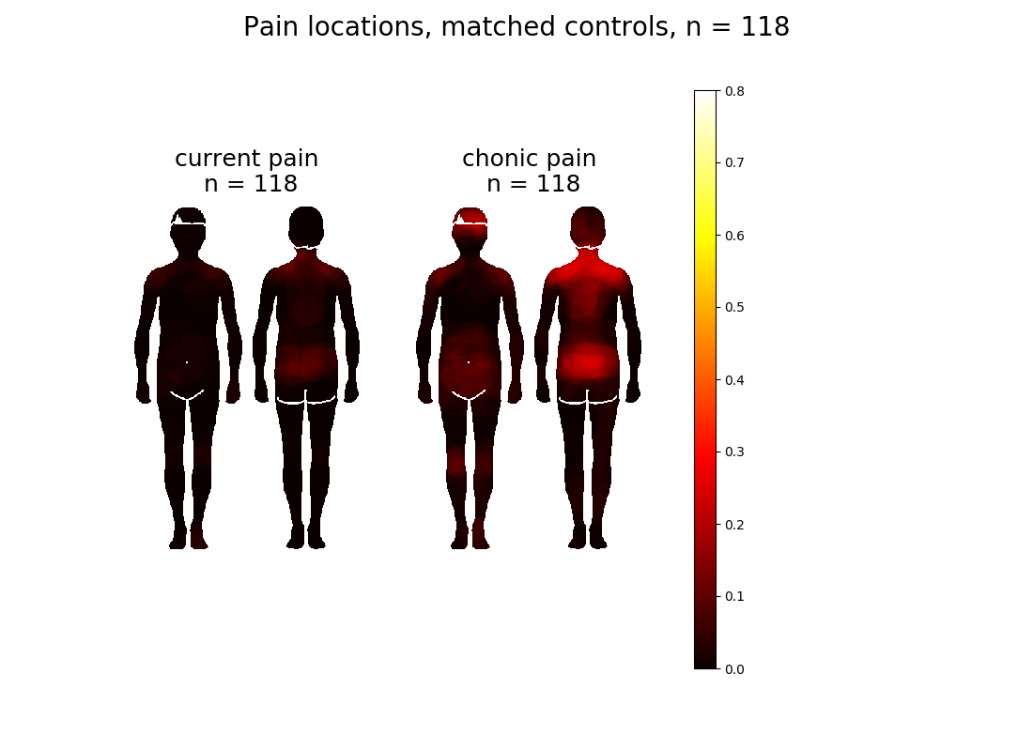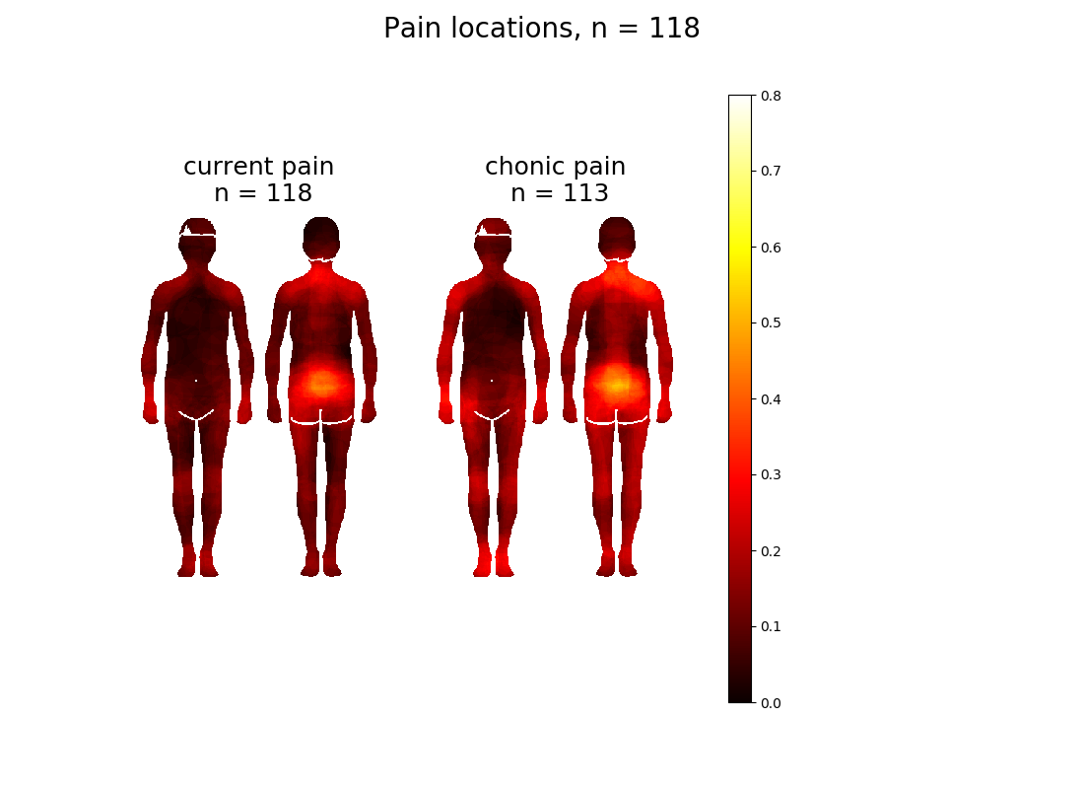

Matched controls marked both chronic and acute pain to low back and abdomen, neck and shoulder area and to the head. Chronic pain patients have a wider spread of both current and chronic pain. Pain patients marked the same areas and also hands and feet. Pain patients marked the joints more clearly.

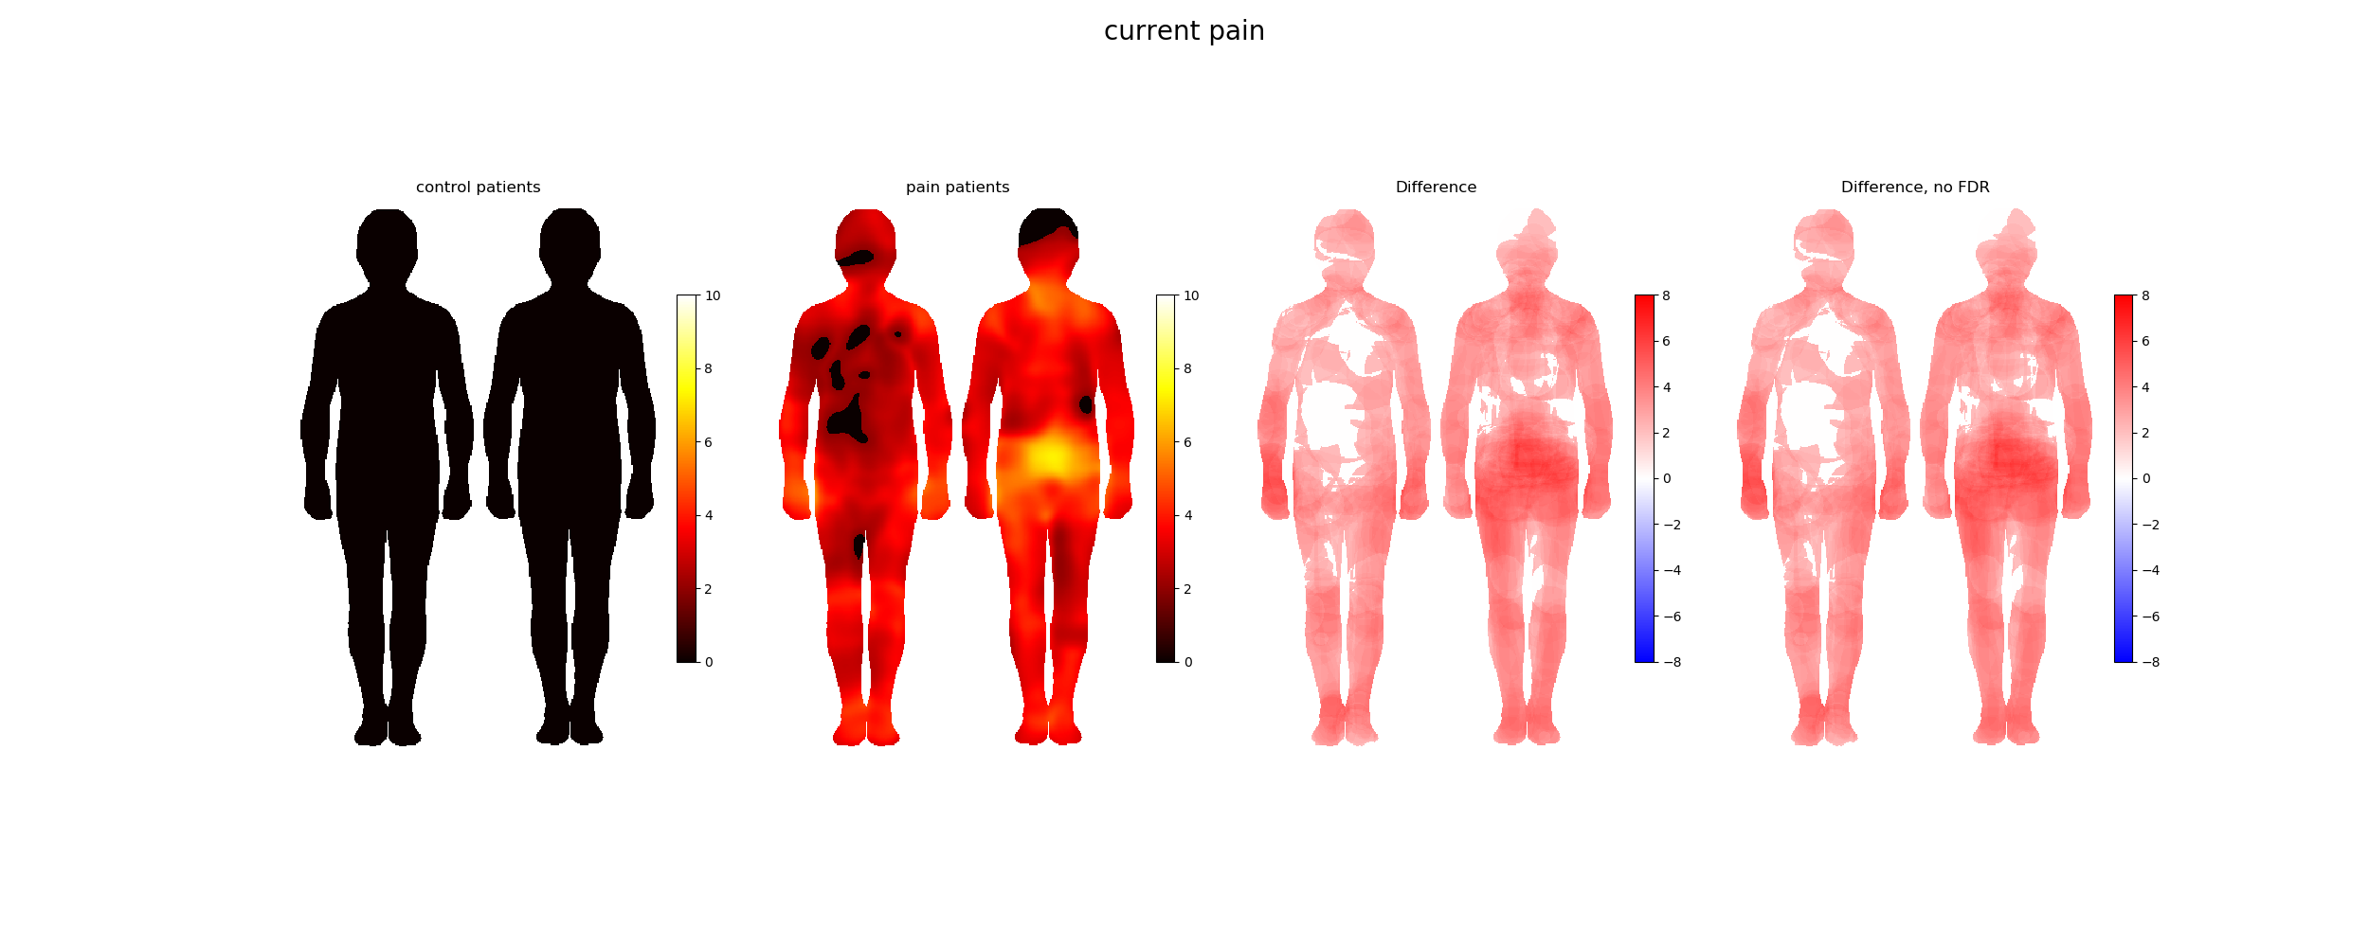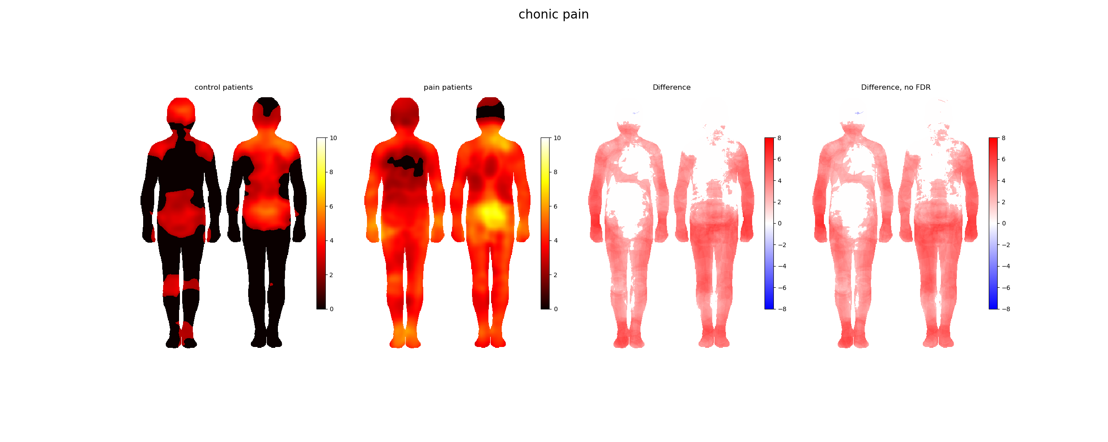

There is some chronic pain in the healthy control group. They painted areas are in the lower and upper back, shoulders, lower abdomen and head. The differences between patients and controls can be seen in the limbs and the lower back. Only the head seems to be equaly painted. Controls were currently almost pain free. Patients painted in both pain types clearly larger areas and the results stay evident after FDR correction.



Patients painted a larger area of the body than the control group. p-values are significant (p<0.001) in both pain types.



In both current and chronic pain the patients mark a larger area than the controls. In the control group the largest marked areas, in chronic pain, are head and torso as seen in body maps before. Patients painted feet, crotch and hands more often than other body areas.

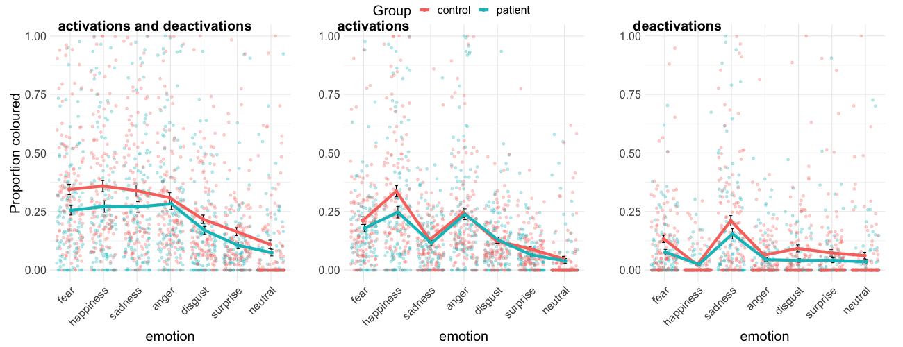

There is a clear difference in proportion of coloured body images between groups. Statistical test for total number of coloured pixels using two-way between-within subjects ANOVA on trimmed means from WRS2 package on R. Significant main effect for emotion (F(6,215.59) = 73.75, p < 0.001. Significant main effect for group F(1, 372.88) = 31.30, p < 0.001. No significant interaction between group and emotion F(6, 214.30) = 1.33, p = 0.2462.

 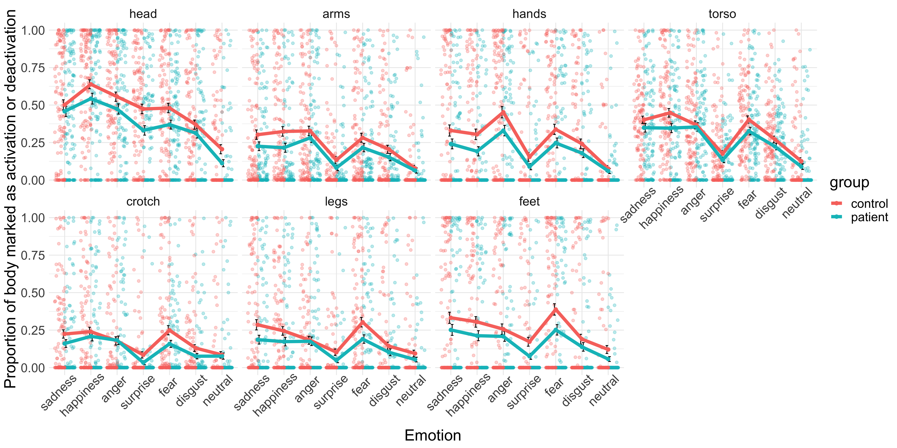

The healthy controls marked a larger amount of pixels than the pain patients. The difference is evident in every emotion in the head, arms, hands, legs and feet. In the torso and the crotch there is some overlap.

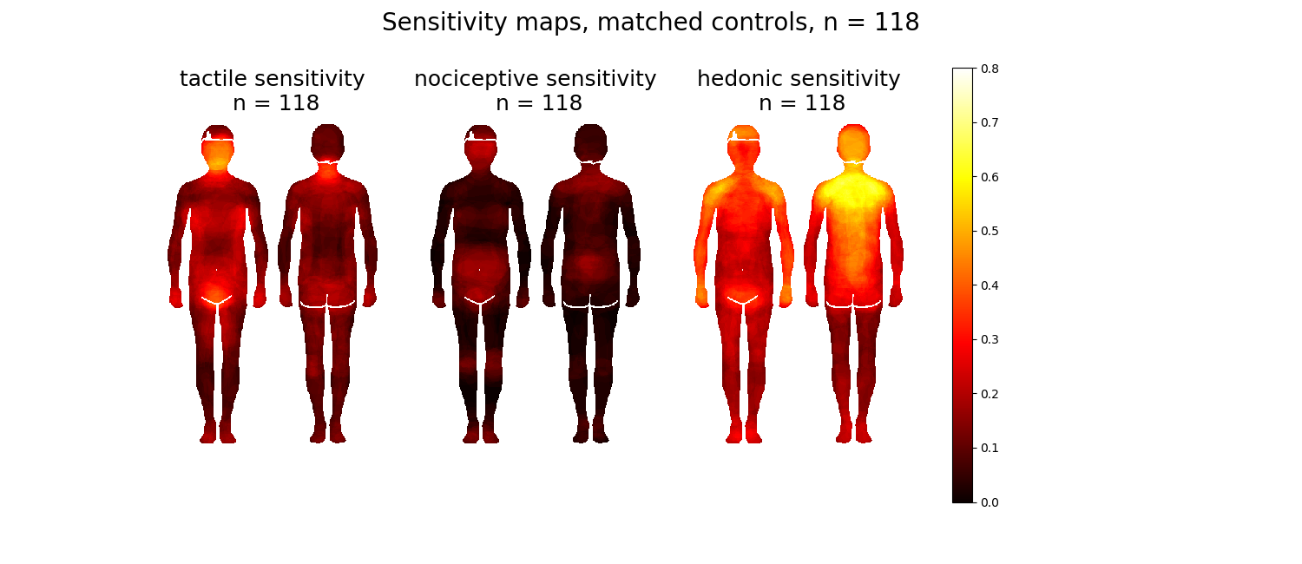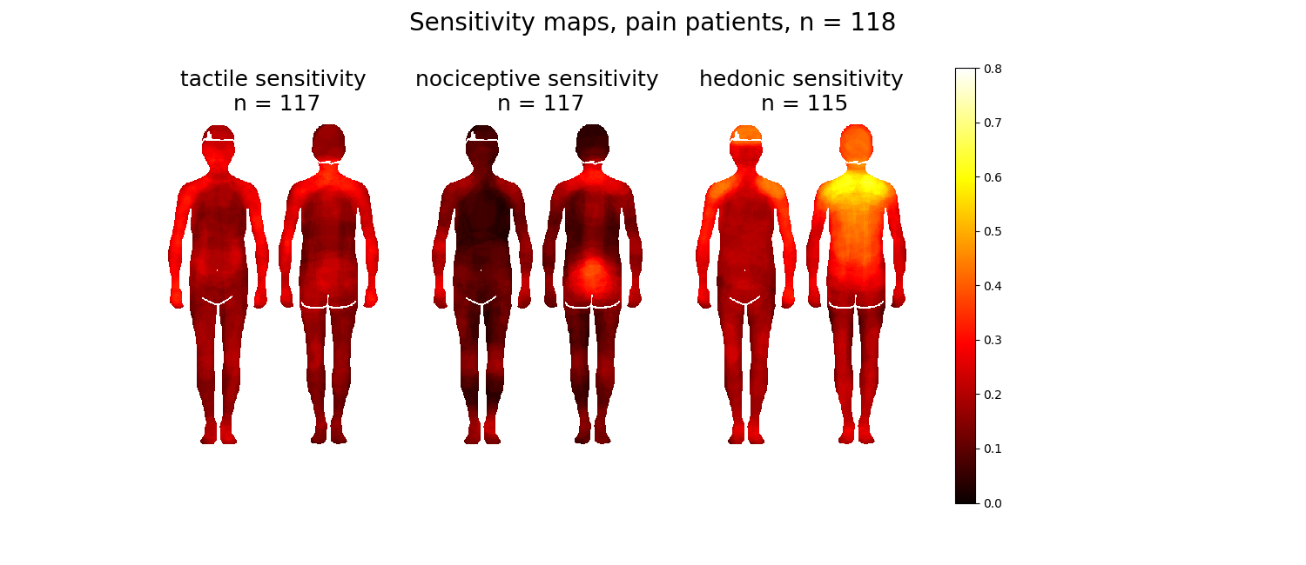

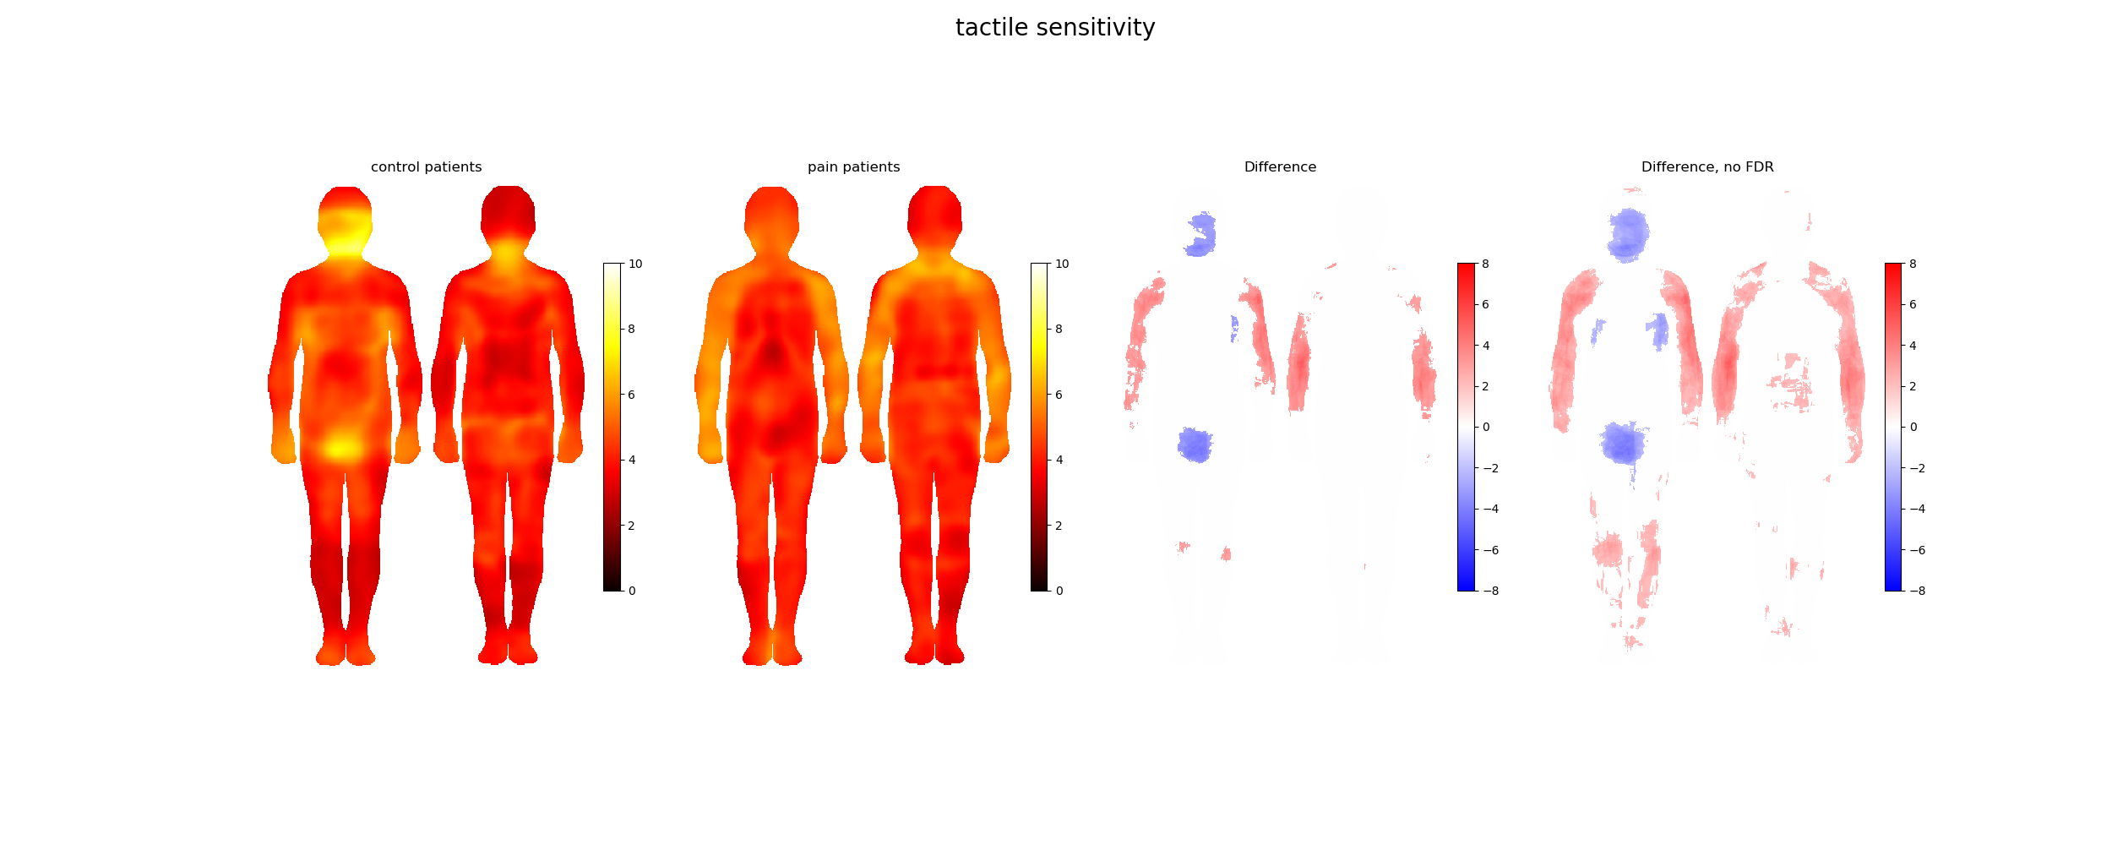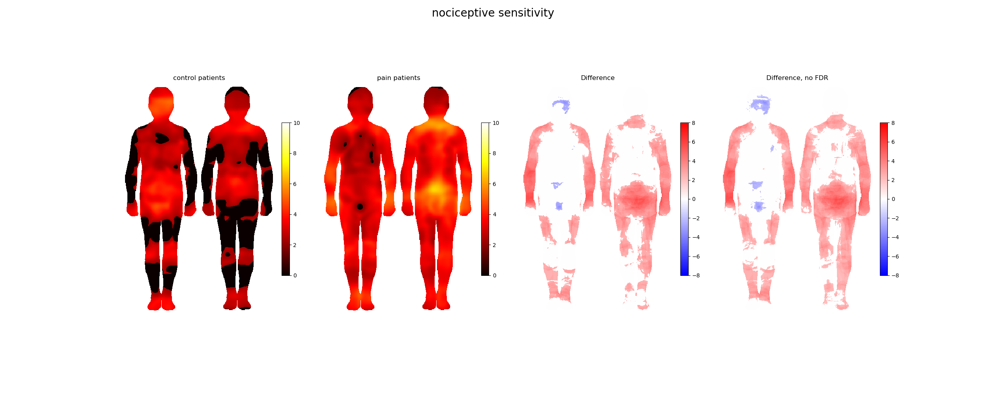

There are clear differences in sensitivity maps. Control group marked more tactile sensitivity to the head and the genital area whereas pain patients were more sensitive in the hands. Pain patients marked larger areas to be sensitive to nociceptive stimulation, especially in the arms, legs and lower back. The controls marked more nociceptive sensitivity only to parts of the head and lower abdomen. There was only small difference in the hedonic sensitivity. When FDR correction was applied the differences in tactile and nociceptive stimulation still stand but there is no variation between groups in hedonic sensitivity.

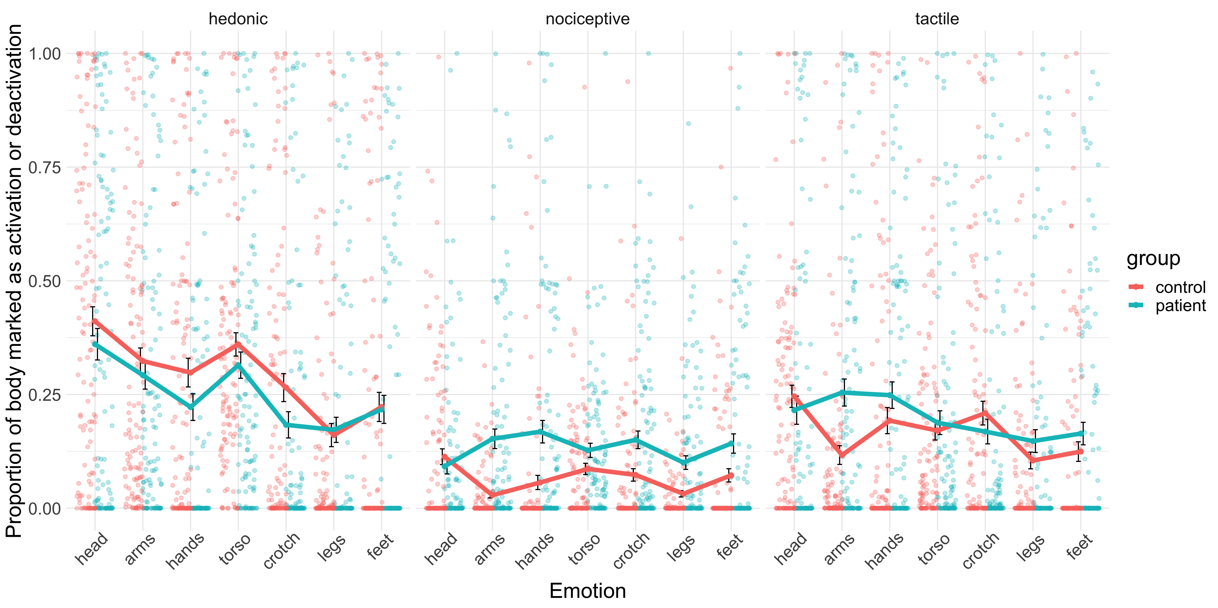

Group comparisons done by Mann-Whitney U test (due to non-normal data). p-values multiple comparison corrected with Holm correction. In nociceptive stimulation the patients marked a larger area. There is no difference in the proportion of painted body area between groups in tactile and hedonic stimulation. The coloured body areas are a little different.



When asked on a scale 0-10 how much of each emotion the participants felt at the moment the patients reported higher rates on all but happiness.

Two-way between-within subjects ANOVA on trimmed means from WRS2 package on R. Significant main effect of group F(1, 84.26) = 96.60, p < 0.001.Significant main effect of emotion type F(8, 73.39) = 46.19, p< 0.001. Significant interaction F(8, 73.39) = 38.89, p < 0.001.



Only significant correlations (p<0.05) are shown in the matrix. There is more and stronger correlation between negatively valenced emotions in the patient group.

Discussio

Potilaat ovat kivuliaampia ja tuntevat enemmän, mutta osaavat merkitä tunteiden sijaintia keholla huonommin.

[1] Hashmi JA, Baliki MN, Huang L, Baria AT, Torbey S, Hermann KM, Schnitzer TJ, Apkarian AV. Shape shifting pain: chronification of back pain shifts brain representation from nociceptive to emotional circuits. Brain 2013;136(Pt 9):2751-2768.

[2] Torregrossa LJ, Snodgress MA, Hong SJ, Nichols HS, Glerean E, Nummenmaa L, Park S. Anomalous Bodily Maps of Emotions in Schizophrenia. Schizophr Bull 2019;45(5):1060-1067.